# Notes 23-03

## Comments on report

GridSpacing was determined based on 2 patients. Don’t mention the conclusion in the results, only mention the conclusion in the discussion. Leave the table in the results.

## Random selection of atlases by registration

Conclude 3 atlasses with NMI, as they are scoring best on our validation set. However, future research can look into this, as the method is not statistical better performing….

* Statistical test between NMI and random selection (check which test to use); mcnemar test

## Grid search machine learning (U-net)

Found out how to do it, however it didn’t work perfectly. Therefore, Christos and Raquel decided to do the grid search manually.

Looked into which parameters are to optimize:

* RMSprop leads to better results
* NAdam also leads to better results.
* Different learning rates are evaluated, however the default values were optimal

AdamW / Adadelta: there is not a lot of research on them.

## SPADE

Milan tried to get it working.

Cian also mentioned that it is possible to have a plan B for the image labels. So we will try it one more time and than continue with an alternative.

## VAE

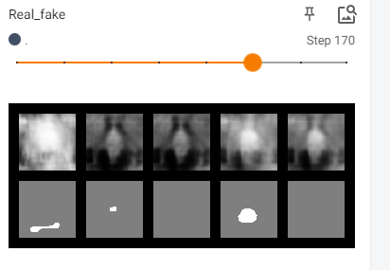 confusing images. Noortje will ask Cian about the black images, how to fix it.

# Next meeting: (Tuesday 9:00 online)

* Raquel: Statistical analysis, discussion about the affine transformation
* Noortje & Milan: look at SPADE
* Noortje & Christos: VAE discussion and try to fix it
* Funmilayo: look into how to generate diverse images
* Christos: write part about U-net findings in the report
* Lotte: understand VAE and look for improvements on the VAE + write discussion about the results of the registration + combine registration codes